Congregatio Immaculati Cordis Mariae (CICM)
Philippines School Network

DEAN OF STUDENT STUDENT AFFAIRS CLUSTER

MINUTES OF MEETING

Date: May 3, 2024
Venue: A 412 (Bishop Constant Jurgens Campus)
Present
- Cirilo R. Parallag Jr., Ll.B, USL, Presider
- Ms. Triceayn Marie D. Prestousa, SLU
- Mr. Jocel R. Opeña, SLC- La Union
- Mr. Samuel B. Damayon, SMU

- The meeting started at 8:05 after the members of the cluster composed of the Guidance, Culture, and Sports agreed to re-arrange and add more chairs and a table and to decide regarding the grouping.

- Roll Call of Participants. The Presider was Mr. Parallag. As there were only four of them, the group recalled the previous plans and even discussed what to maintain or continue and what to modify.

- Meeting Proper. The following agenda was discussed during the meeting.

Agenda | Discussions | Remarks
- On Review on Organizational structure of all CICM schools, specifically on Organizational Development programs | The group decided to share the SOPs and Procedures of their respective offices.  A Google Drive will be created where the documents will be uploaded. Whatever will be common or worth sharing and capturing will be discussed online or when they meet in September for the CICM Student Leadership Convergence.  The target date will be August to October 2024.
- On Collaborative formation of student leaders | The Deans maintained the annual conduct of the CICM Student Leadership Convergence which will be participated by student leaders. As a practice, around 25 participants from each school will join.  The host school will be St. Mary’s University and the tentative date will be on September 18-21, 2024.
 | Also, as previously planned for this Academic Year is the Search for Ten Outstanding CICM Student Leaders. However, the Deans were only able to craft the guidelines. Hence, they target August 2024 for the approval of the TOCSL guidelines in August.  Once approved, search and awarding will be announced starting January 2025 and students will be conferred before the end of the second semester in May 2025. | Other details of the search will be discussed by the Deans, once the guidelines are approved.
- On Collaboration among student affairs practitioners | The Deans agreed among themselves to also involve the development of their staff. Thus, during the CICM Student Leadership Convergence, the group will invite Fr. Jess Hechanova, CICM to talk about Verbistian Leadership. This will somehow be a parallel session while the student- participants will attend a separate talk.  In addition, to add color to the 60th founding anniversary of USL, Atty. Joseph Noel Estrada may be invited to talk on Student Discipline. He can be requested through Rex Bookstore. The group thought of this plan because, in the past, the founding anniversary of USL was integrated with the CICM Friendship Meet. Suppose this plan of the group is granted. In that case, a group of 25 students with student affairs practitioners as their chaperon will be able to witness not only the festivities of the University but to benchmark as well regarding how our own school and student leaders prepare for such a big event aside from attending the talk.
- On the unification of the principles of restorative justice | Before the next academic year starts, the integration of common statements on restorative justice in the college student handbook shall have been approved by the respective University Presidents. This has to be done as handbooks have to be readily available before classes start.
- On Collaborative research on CICM graduate attributes | As agreed upon by the group, pilot testing of the survey questionnaire will be done in June 2024 at SLU and SMU. Considering that these schools have graduation programs in January 2025, the survey questionnaire will be administered to the identified graduating students.
- On Collaborative research on CICM graduate attributes | Additional activity will be the conduct of a CICM Friendship Meet Post and Pre- Planning Meetings.  The post-planning meeting is scheduled in September, where evaluation may be conducted. Meanwhile, the pre-planning will also be scheduled later.

IV. Adjournment. The meeting adjourned at 2:28 PM.

Prepared by:

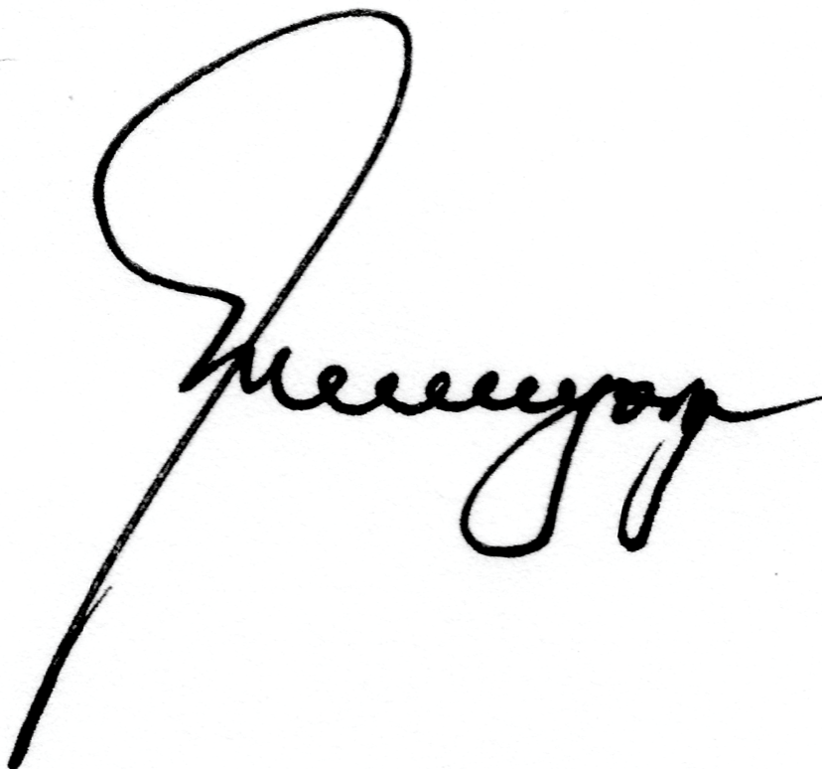
MARIA LEONORA M. CAGURANGAN, Ed. D.
IDQA Assistant Director for Basic Education School
University of Saint Louis

Attested by:

CIRILO R. PARALLAG JR. Ll.B.
Dean of Student Affairs and Services
University of Saint Louis

